## Theory and Concept

###### Objective:-To Implement the restrictions/constraints on the table.

**Data constraints:** Besides the cell name, cell lengthand cell data type there are other parameters i.e. other data constrains that canbe passed to the DBAat check creationtime. The constraints caneither be placed at column level or at the table level.

1. **Column Level Constraints:** If the constraints are defined along with the column definition, it is called a column level constraint.
2. **Table Level Constraints:** If the data constraint attached to a specify cell in a table reference the contents of another cell in the table then the user will have to use table levelconstraints.

**NullValue Concepts:-**while creating tables ifa rowlocksa datavalue for particular column that value is said to be null . Column of any data types may contain null values unless the column was defined as not null when the table was created

Syntax:

**Create table tablename**

**(**column name datatype(size)not null……)

**Primary Key:** primary key is one or more columns is a table used to uniquickly identity each row in the table. Primary key values must not be null and must be uni Question across the column. A multicolumn primary key is called composite primary key.

Syntax:primarykeyasacolumn constraint

Createtabletablename

(columnnamedatatype(size)primarykey,….)

Primarykeyasatable constraint

Createtabletablename

(columnnamedatatype(size),columnnamedatatype(size)… Primary key (columnname,columnname));

**UniQuestion key concept:-**A uniQuestion is similar to a primarykey except that the purpose of a uniQuestion key is to ensure that information in the column for each record isuniQuestion as with telephone or devices license numbers. A table may have many uniQuestion keys.

Syntax: UniQuestionasacolumnconstraint.

Createtabletablename

(columnnamedatatype(size)uniQuestion);

UniQuestionastable constraint:

Createtabletablename

(columnname datatype (size),columnname datatype (size)…uniQuestion (columnname,columnname));

**Default valueconcept: At** the lineofcellcreationadefault valuecanbeassignedto it. When the user is loading a recordwith values and leaves this cellempty, the DBAwilautomatically load this cell withthe default value specified. The datatype ofthe default value should match the data type of the column

Syntax:

Createtabletablename

(columnnamedatatype(size)default value,….);

**Foreign Key Concept :**Foreign key represents relationship between tables. A foreign key is column whose values are derived from the primary key of the same of some other table . the existence of foreign key implies that the table with foreign key is related to the primary key table from which the foreign key is derived .A foreign key must have corresponding primary key value in the primary key table to have meaning.

Foreignkeyas a columnconstraint

Syntax:

Createtabletablename

(columnnamedatatype(size)referencesanothertablename);

Foreignkeyasatableconstraint:

**Syntax:**

Create table name(columnnamedatatype(size)…. primary key (columnname);

foreignkey(columnname)referencestablename);

**Check Integrity Constraints:** Use the check constraints when you need to enforce intergrity rules that can be evaluated based on a logical expression following are a few examples of appropriate check constraints.

* A check constraints name column of the coient_master so that the name is entered in upper case.
* A check constraint on the client_no column of the client _master so that no client_no value starts with ‘c’

Syntax:

Createtabletablename

(columnnamedatatype(size)CONSTRAINTconstraintname) Check (expression));

**Question.2Createthefollowing tables:**

1. **Sales_master**

|  |  |  |  |
| --- | --- | --- | --- |
| **Columnname** | **Datatype** | **Size** | **Attributes** |
| Salesman_no | varchar2 | 6 | Primarykey/firstletter |
|  |  |  | muststartwith‘s’ |
| Sal_name | varchar2 | 20 | Notnull |
| Address | varchar2 |  | Notnull |
| City | varchar2 | 20 |  |
| State | varchar2 | 20 |  |
| Pincode | Number | 6 |  |
| Sal_amt | Number | 8,2 | Notnull, cannotbe0 |
| Tgt_to_get | Number | 6,2 | Notnull, cannotbe0 |
| Ytd_sales | Number | 6,2 | Notnull, cannotbe0 |
| Remarks | Varchar2 | 30 |  |

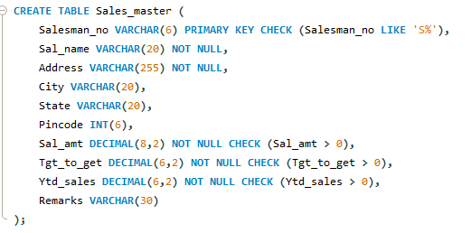

1. **Sales_order**

|  |  |  |  |
| --- | --- | --- | --- |
| **Columnname** | **Datatype** | **Size** | **Attributes** |
| S_order_no | varchar2 | 6 | Primary/firstlettermustbe0 |
| S_order_date | Date | 6 | Primarykeyreferenceclientnoof client_master table |
| Client_no | Varchar2 | 25 |  |
| Dely_add | Varchar2 | 6 |  |
| Salesman_no | Varchar2 | 6 | Foreign key references salesman_noofsalesman_mastertable |
| Dely_type | Char | 1 | Deliverypart(p)/full(f),defaultf |
| Billed_yn | Char | 1 |  |
| Dely_date | Date |  | Cannotbelessthans_order_date |
| Order_status | Varchar2 | 10 | Values(‘in  process’;’fulfilled’;backorder’;’canceled |

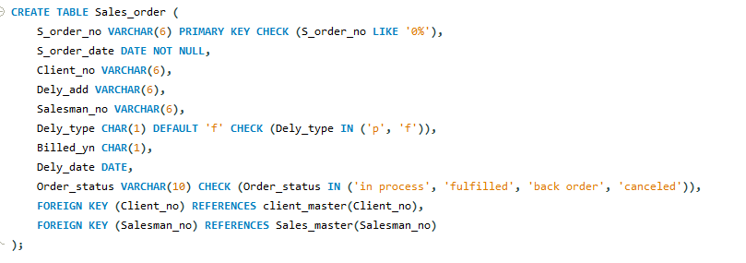

* 1. **Sales_order_details**

|  |  |  |  |
| --- | --- | --- | --- |
| **Column** | **Datatype** | **Size** | **Attributes** |
| S_order_no | Varchar2 | 6 | Primarykey/foreignkey  referencess_order_no of sales_order |
| Product_no | Varchar2 | 6 | Primarykey/foreignkey references product_no  ofproduct_master |
| Qty_order | Number | 8 |  |
| Qty_disp | Number | 8 |  |
| Product_rate | Number | 10,2 |  |

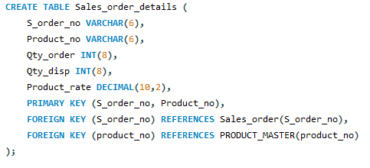

Insertthe followingdataintotheirrespectivetablesusing insertstatement:

Dataforsales_manmastertable

|  |  |  |  |  |  |  |  |  |  |
| --- | --- | --- | --- | --- | --- | --- | --- | --- | --- |
| **Salesman_no** | **Salesman name** | **Address** | **City** | **Pin code** | **State** | **Salamt** | **Tgt_**  **to_get** | **Ytd Sales** | **Remark** |
| 500001 | Kiran | A/14worli | Bomba  y | 400002 | Mah | 3000 | 100 | 50 | Good |
| 500002 | Manish | 65,nariman | Bomba  y | 400001 | Mah | 3000 | 200 | 100 | Good |
| 500003 | Ravi | P-7Bandra | Bomba  y | 400032 | Mah | 3000 | 200 | 100 | Good |
| 500004 | Ashish | A/5 Juhu | Bomba  y | 400044 | Mah | 3500 | 200 | 150 | Good |

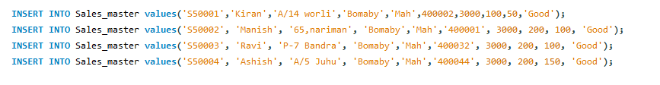

1. Dataforsalesordertable:

|  |  |  |  |  |  |  |  |
| --- | --- | --- | --- | --- | --- | --- | --- |
| S_orderno | S_orderdate | Clientno | Dely  type | Bill yn | Salesmanno | Delay  date | Orderstatus |
| 019001 | 12-jan-96 | 0001 | F | N | 50001 | 20-jan-96 | Ip |
| 019002 | 25-jan-96 | 0002 | P | N | 50002 | 27-jan-96 | C |
| 016865 | 18-feb-96 | 0003 | F | Y | 500003 | 20-feb-96 | F |
| 019003 | 03-apr-96 | 0001 | F | Y | 500001 | 07-apr-96 | F |
| 046866 | 20-may-96 | 0004 | P | N | 500002 | 22-may-  96 | C |
| 010008 | 24-may-96 | 0005 | F | N | 500004 | 26-may-  96 | Ip |

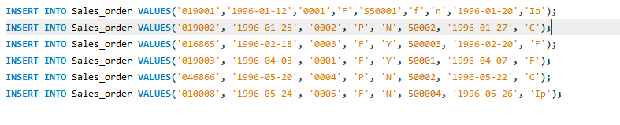

(iii)

**Dataforsales_order_detailstable:**

|  |  |  |  |  |
| --- | --- | --- | --- | --- |
| S_orderno | Productno | Qtyordered | Qtydisp | Product_rate |
| 019001 | P00001 | 4 | 4 | 525 |
| 019001 | P07965 | 2 | 1 | 8400 |
| 019001 | P07885 | 2 | 1 | 5250 |
| 019002 | P00001 | 10 | 0 | 525 |
| 046865 | P07868 | 3 | 3 | 3150 |
| 046865 | P07885 | 10 | 10 | 5250 |
| 019003 | P00001 | 4 | 4 | 1050 |
| 019003 | P03453 | 2 | 2 | 1050 |
| 046866 | P06734 | 1 | 1 | 12000 |
| 046866 | P07965 | 1 | 0 | 8400 |
| 010008 | P07975 | 1 | 0 | 1050 |
| 010008 | P00001 | 10 | 5 | 525 |

